MAIN TRENDS OF THE SAMBIANN COASTAL SYSTEM (SOUTH-EASTERN BALTIC) DEVELOPMENT: HOLOCENE LITHODYNAMICS AND RECENT COASTAL PROCESSES
Daria Ryabchuk, A.P. Karpinsky Russian Geological Research Institute (VSEGEI), Immanuel Kant Baltic Federal University (BFU), daria_ryabchuk@vsegei.ru
Alexander Sergeev, A.P. Karpinsky Russian Geological Research Institute (VSEGEI), Immanuel Kant Baltic Federal University (BFU)
Vadim Sivkov, Immanuel Kant Baltic Federal University (BFU), Atlantic Branch of P.P. Shirshov Institute of Oceanology (ABIO RAS)
Vladimir Zhamoida, A.P. Karpinsky Russian Geological Research Institute (VSEGEI), Immanuel Kant Baltic Federal University (BFU)
Olga Kovaleva, A.P. Karpinsky Russian Geological Research Institute (VSEGEI), Immanuel Kant Baltic Federal University (BFU)
Eugenia Dorokhova, Immanuel Kant Baltic Federal University (BFU), Atlantic Branch of P.P. Shirshov Institute of Oceanology (ABIO RAS)

Abstract. Synthesis of long-term geological research of the Russian part of the southeastern Baltic and its coastal zone allowed to establish boundaries, time of forming and structure of Sambian morpho-lythodynamic marine and coastal system. Studied system includes coastal zone (by the water depth about 30 m according to longshore storm wave currents impact) and adjacent silty-clay sedimentation basins. Development of Curonian Spit area in Late Pleistocene – Holocene was reconstructed based on marine geological and geophysical study and modeling. Comparative analyses of geological settings of the Curonian and Vistula Spits and lagoons has shown that the mechanisms of their development is significantly different. By late Holocene, the study area of southeastern Baltic Sea consisted of several lithodynamic coastal systems. By 5 ka BP both lagoon systems were formed. Evolution of spits and lagoons during last 5000 years caused development of similar morphological features. Vistula and Curonian lagoons transformed into sediment traps for alluvial deposits of Neman and Pregola rivers. Smoothening of the shoreline as a result of longshore sediment drift is a dominate coastal process.

Key words: lithodynamics, morpho-lithodynamic system, Holocene, Sambian Peninsula, Baltic Sea
- INTRODUCTION
Long history of investigations of the southeastern Baltic geology, geomorphology and coastal processes started in the end of 19th – beginning of 20th centuries by German scientists J. Schumann, G. Berendt, J. Abromeit, A. Tornquist and continued after the Second World War by specialists from P.P. Shirshov Institute of Oceanology of Russian Academy of Sciences (IO RAS) with Atlantic Branch (AB IO RAS) [1], [2], [3] and Lomonosov Moscow State University (MSU) [4], [5]. Considerable geological, geomorphologic and lithodynamic research of the Curonian Spit and lagoon was undertaken by Lithuanian scientists [6], [7], [8], [9], [10], [11], while the Vistula Spit and lagoon were studied by Polish specialists [12], [13], [14]. During last decade Atlantic Branch of IO RAS, A.P. Karpinsky Russian Geological Research Institute (VSEGEI) and Immanuel Kant Baltic Federal University (BFU) carried out significant amount of marine geological and geophysical investigations, allowed to receive detailed information about Quaternary geological settings, bottom and coastal relief and surface sediments distribution. Synthesis of long-term geological research of the Russian part of the southeastern Baltic and its coastal zone gives the opportunity to develop the conception of the Sambian morpho-lithodynamic system evolution and to find the lack of knowledge.
The aim of this article is to summarize geological and geophysical data obtained in 2005-2015 in the Russian sector of the southeastern Baltic and compared their results with the Polish and Lithuanian data in order to create a single regional model for the coastal zones formation. Coastal zone evolution as a result of long-term processes of sediment and energy interchange between land and sea is possible to examine using conception of morpho-lithodynamic system. Morpho-lithodynamic system of the southeastern Baltic includes coastal zone (by the water depth about 30 m according to longshore storm wave currents impact) and adjacent silty-clay sedimentation basins. The main task of such approach is to establish boundaries, time of forming and structure of the studied system.

- MATERIAL AND METHODS
In 1993-2002 VSEGEI, ABIO RAS and Kaliningrad Hydrogeological Expedition carried out joint studies, aimed to generalize the geological, geophysical and cartographic information concerning seafloor geological structure of the southern Baltic Sea within the economic zone of the Russian Federation. The geological maps (1:200 000 and 1:500 000 scales) previously compiled for this area by VNIIMORGEO Institute in 1970-1986 on the base of the geological survey and geotechnical works, have been substantially modified using modern geological and geophysical data obtained by VSEGEI and AB IO RAS. As a result of joint efforts the set of maps (1:200 000) including Bedrock and Quaternary Geological maps combining with the maps of economic deposits, maps of Distribution of Bottom Sediments and Environmental Geological maps accompanying by Explanatory note were compiled [15]. This set of maps was not published and stored in the archives of VSEGEI and the Federal Agency for Mineral Resources of the Russian Federation. Further geological and geophysical studies have shown high reliability of these maps, at least, at the sea depths more than 5-10 m. In 2005-2008 geological studies of VSEGEI and AB IO RAS were concentrated mainly on the coastal zone of the Kaliningrad region and adjacent offshore areas, as well as in the Curonian and Vistula lagoons, or the areas which are most variable in terms of bottom sediment distribution and transformation of bottom topography. Detail maps of bottom sediments distribution in the shallow key areas adjacent to the Sambian Peninsula, as well as Vistula and Curonian spits, were developed on the base of data obtained by side-scan sonar profiling and sediment sampling. Extensive areas of bottom erosion, which are marked by outcrops of the glacial moraine and bedrock were identified and mapped. The assumption of the lack of sediment load along the northern coast of the Sambian Peninsula, which is one of the main causes of the beach degradation in this area, was confirmed. Outcrops of relict lagoon sediments were identified and mapped at the sea coastal slope offshore Curonian Spit. At the same time a pilot version of the electronic cadastre of the Kaliningrad region coastal zone has been developed. It contained the modern information about the structure and dynamics of the coasts, as well as sets of multiscale combined (land - sea) geological and environmental geological maps.
The new information about the geological structure of the sea bottom has been obtained while conducting research by AB IO RAS, VSEGEI and other organizations within the framework of "LUKOIL-KMN", Ltd. environmental monitoring of offshore oil field "Kravtsovskoye» (D-6). As a result of this work, pockmarks occurrence and underwater landslides on the slopes of the Gdansk Basin were identified. These investigations also included assessment of environmental geological conditions in the Russian part of the southeastern Baltic Sea, concentrated on the study of bottom sediment contamination by heavy metals, organic compounds and petroleum.
In 2010 VSEGEI together with AB IO RAS compiled and published the Atlas of geological and environmental geological maps of the Russian area of the Baltic Sea (1:700 000 scale) [16] and the State Geological maps of Kaliningrad Region (1:1 000 000 scale) [17] which accumulated all newest information about the geological structure of the region.
In 2011-2015 VSEGEI and AB IO RAS began a new stage of geological exploration of the coastal areas. The main specification of this stage is a high resolution of obtained materials by carrying out continuous aerial surveys of the seabed using side-scan sonar and multibeam, as well as network of seismic-acoustic profiling and monitoring sediment sampling. To the west of the Sambian Peninsula several scarps of ancient coastlines were traced and mapped; the evidence of glaciotectonics was fixed; the area of accumulation of technogenic sediments, dumped by the Amber Plant, was located and thickness of these sediments were measured; underwater outcrops of the Paleogene rocks, including amber bearing layers were differentiated. To the north of the Sambian Peninsula some palaeovalleys were identified; areas of bottom erosion and outcrops of pre-Quaternary rocks were clarified. Outflow runnels and specific diapirs formed by relict lagoon muds were found in the area adjacent to the Curonian Spit. Near the Russian-Lithuanian border the offshore area of ground water discharge, which probably associated with deposits of Palaeo-Neman River was presumably identified. New geological and geophysical data allowed to develop noncontradictory palaeogeographic schemes of regional development during the Late Pleistocene - Holocene, as well as to forecast development of the coastal zone of Kaliningrad region.
- RESULTS AND DISCUSSION
Palaeogeographical analyses
Southeastern part of the Baltic Sea (in boundaries of the Russian Federation) is located at the southwestern flank of the Russian Plate. The Archean-Proterozoic metamorphic basement is covered by the sedimentary cover of almost all Cambrian-Paleogene ages except Carboniferous [16]. General contour of shoreline is controlled by geology and tectonics. Sambian Peninsula is located within vast uplifted part of “Kaliningrad megaswell”, divided the Curonian and Vistula depressions with cognominal lagoons [5].
The most self-evident since the time of first palaeogeographical reconstructions of the study area was development of the Sambian Peninsula. Significant shifted seaward and composed of easily erodible Paleogene-Quaternary deposits, it has been constantly eroded during postglacial history. First rather conflicting hypothesis of submerged Holocene wave-cut cliffs (submerged coastlines) and terraces location were presented by several authors based on bathymetric data analyses [8], [9], [18]. Recent detailed geophysical investigations and GIS analyses revealed several areas of the maximum slope lines, assumed to correspond to wave-cut cliff axes. A total of five axial lines of post-glacial wave-cut cliffs were identified: two dated to the Yoldia Sea (58–45 and 52–40 m), one assigned to the Ancylus Lake (38 m), and two dated to the Litorina Sea (29 and 21 m) [19]. All late-postglacial coastlines are located beneath recent sea level.
The question of time and mechanism of the Curonian and Vistula spits formation has a fundamental importance for determining of age of the Sambian morpho-lithodynamic system. Before lagoons formation alluvial deposits of Neman, Vistula and Pregola rivers discharged into the Baltic Sea Basin. Despite morphological similarity of the Curonian and Vistula Spits, results of geological investigations pointed out significant differences in their development, caused by tectonic regime, pre-Holocene relief and sources of sediment material.
To the southwest of the Sambian Peninsula, the line of the Gardno end-moraines (Gardno Phase) is situated near the coasts. It is traced along the shore of the Vistula Lagoon, formed landward curve in the area of the Vistula River delta and goes in western direction within Polish coastal zone [12], [14]. Within the Sambian Peninsula and further to north-east the end moraine of the same stage (Mid-Lithuanian) [20], [21] change direction, forming large smooth landward curve. To the south-west from the Sambian Peninsula, all Late Pleistocene shorelines were located below recent sea level. Deposits of the Baltic Ice Lake (BIL) did not find onshore. The young phase of BIL dated by peat layers in the Pomeranian Bay; its transgressive phase studied in sediment complex of palaeodelta of Vistula River. BIL level is estimated as -30 - -25-22 m b.s.l. [14].
To the north-east of the Sambian Peninsula the BIL clays are spread within glacial till depressions seaward from the Curonian Spit (water depth more than -25 m b.s.l.), in the Curonian Lagoon from 12..-15 m b.s.l. in the southern part [10] to 20 m b.s.l. in central part and to -25..-28 m b.s.l. in front of the Rybachy village. Thickness of BIL deposits in the borehole of central part of the Curonian lagoon is more than 10 m. In the northern (Lithuanian) part of the lagoon BIL deposits are wide spread, but their thickness is less [22]. Sandy facies of BIL are mapped during the geological survey in the coasts of both Curonian and Vistula lagoons. Taking into account difference in the tectonic subsidence rates (Fig.1), their occurrence can be easily explained for the Curonian Lagoon but it is rather contradictory with existing hypothesis of BIL sea level for the Vistula lagoon. For solving this problem extra research and dating is needed.
Late Pleistocene relief controls land and sea bottom morphology, as well as structure and composition of overlaying Holocene deposits. Results of geomorphological modeling revealed dependence of development and recent position of the Curonian Spit.
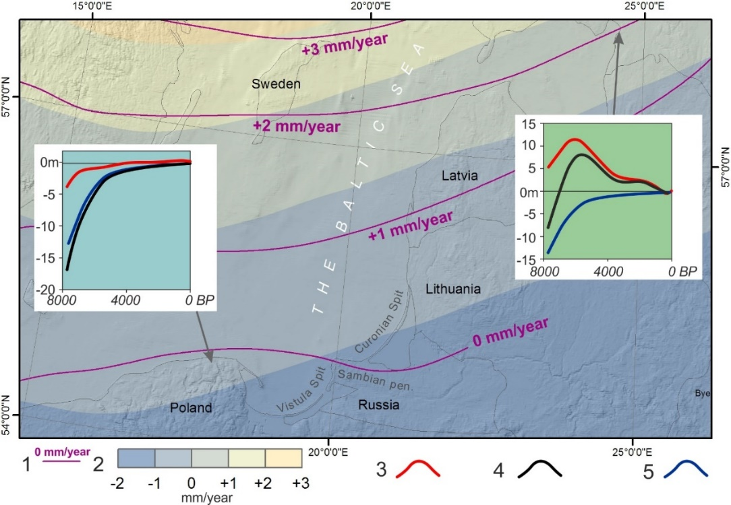
Fig. 1. Vertical crustal displacement (mm/year) for the twentieth century: 1 – isobases by [23]; 2 – isobases by [24]. Graphs: 3 – the isostatic component; 4 – relative sea level change; 5 – the eustatic curve.

Late Pleistocene relief within Baltic Proper in front of the Curonian Spit is rather dissected (Fig. 2) with several basins, ridges and narrow runnels. Runnels are up to 10 m of relative depth are located within Palaeo-Neman area and most probably have erosion origin. Late Pleistocene surface within the Curonian Lagoon is subdivided into two separate basins. Many features of modern relief are inherited from Late Pleistocene surface. GIS hydrological modeling allowed to trace possible location of palaeorivers valleys in Early Holocene – linked with palaeo-Neman in the east, palaeo-Deima in the south and the third (southwestern) under attached part of the Curonian Spit [25].
In the area of the Vistula Spit, deposits of Weichselian glaciation and Late Pleistocene postglacial basins were remained only in a few occurrences of significantly reduced thickness mainly as sands with gravel. Their surface is eroded; a degree of destruction increases in the eastern direction. Late Pleistocene deposits are identified in the Sztutowo area at -20-16 m b.s.l. and in the Przebrno area at -21-20.5 m b.s.l. [13].
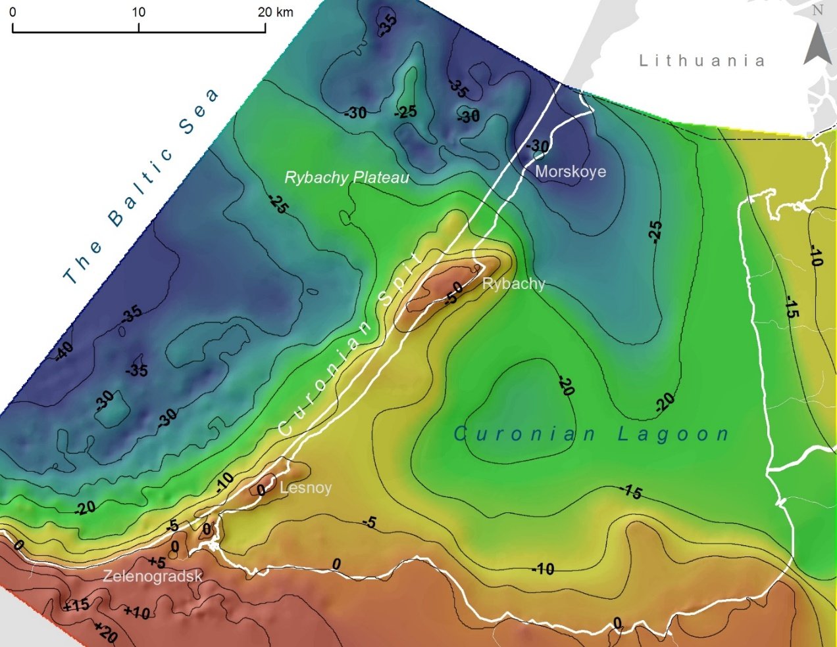
Fig. 2. Model of Late Pleistocene relief (m m.s.l.)

In Early Holocene as a result of BIL final drainage, water level dropped by -55-60 m b.s.l. along within its southwestern part [12], [14], the Baltic Basin was connected with the ocean, forming the Yoldia Sea. The next palaeobasin – fresh-water Ancylus Lake – was formed after 25 m transgression, caused by glacioisostatic rebound [12]. Level of the Ancylus Lake by the end of Early Holocene in the Gdansk Bay reached -20 m b.s.l. To north-east of the Sambian Peninsula deep-water facies of the Ancylus Lake are found at sea water depth -80 m b.s.l. [15], [16].
Significant differences were revealed in Holocene geological settings of the Curonian and Vistula Spits. Thickness of Holocene deposits within the Russian part of the Curonian Spit increases from southwest to northeast from 1-5 m to 40-80 m (under dune massifs). Along some areas of attached part of the spit and in the vicinity of the Rybachy village, their thickness is less than 1 m [25]. On the contrary, Holocene deposits of the Vistula Spit are characterized by consistent thickness of about 20 m.
In the boreholes, located in the Russian part of the Curonian Spit, Early Holocene deposits are absent with exception of southern part of the spit in the vicinity of Morskoye village [4], where they are represented by unsorted sands. In the Lithuanian part of the Curonian spit and lagoon surface of Early Holocene deposits, submerging seaward, is locate at depth from -6 to -10 m b.s.l., with local valleys up to -15..-20 m b.s.l. [22].
The best preserved areas of the Ancylus Lake deposits according to boreholes data are found in the Curonian Lagoon [10]. They are presented by sands; its surface is established at a depth from -4 to -18 m b.s.l., with decreasing of thickness in eastern and southern directions. Along eastern and southern coasts of the Curonian Lagoon, thickness of Ancylus deposits is less than 1 m and absent completely within Neman delta plain.
Palaeoreconstructions of the Curonian Spit area in Holocene, based on undertaken research, are shown on Fig. 3. According to data of Ancylus Lake level [1], [7], [14], it is possible to conclude, that palaeorivers were the main source of sediment material for the deposition within the Curonian Lagoon basin during Early Holocene. Within the Baltic Basin shoreline of the Ancylus Lake located near modern isobaths -60 m. In the bottom depressions of the central part of the Curonian Lagoon could be located small fresh-water lakes. In the northern part of the Curonian Lagoon, connected with the open part of the Baltic Basin during period of the lowest water level, deltaic sand accumulation took place.
During the first stage of the Litorina Sea development, coastal line was located at depth -25 m b.s.l. Isolated fresh-water lake occurred in the Curonian Lagoon Basin. During maximal phase of Litorina transgression (about +3 m a.s.l.), ridges and the plateau of the Curonian Spit and the Rybachy Plateau areas were submerged. Area of the Curonian Lagoon was an open bay of the Litorina Sea, possibly partly separated just by several small islands. Due to active hydrodynamics, bottom erosion and redeposition of sediment material dominated within study area after maximal phase of the Litorina transgression.
Investigations of the Baltic Sea bottom along the southern half of the Curonian Spit using side-scan sonar, multibeam echosounder, seismic imaging, sediment sampling, and video observations allowed identification and mapping of a unique underwater landscape formed by extensive outcrops of laminated and folded lagoon marl at water depths of 5–15 m. The relict lagoon marl was deformed, compacted, and dehydrated by a massive dune-covered coastal barrier migrating landward (retrograding) over these sediments during the Litorina Sea transgression in a process termed “dune tectonics”. Offshore lagoon marl ridges form an extensive complex about 5 m (up to 8-10 m) thick; modern marine sands [26] cover described complex. A conceptual palaeogeographic model of the occurrence of relict lagoon marl extrusions (diapirs) in the underwater coastal slope of the Curonian Spit is shown at Fig. 3 (7500 ka BP).
Along marine coast of the Curonian Spit in the vicinity of Zelenogradsk town, Lesnoy and Rybachy villages, the peat and palaeosols layers were founded at depth about -1 m b.s.l. Results of radiocarbon dating have shown that during last 5000 years slow shifting of the Spit toward lagoon due to increasing of sea level was the main trends of the Curonian Spit development [27].
Consequently, the Curonian Spit was developed during Holocene on postglacial surface (e.g. glacial moraine ridges remains) as polygenic accretion form. During the first stages of the Curonian Spit development (regressive phase after the Litorina transgression maximum) both cross-shore and long-shore sediment transport were sources of sediment material, as a result of erosion of the Sambian Peninsula, Rybachy Plateau and deltaic sediments. Smoothed contour of spit shoreline was formed during last 5000 years mainly as a result of longshore sediment drift.
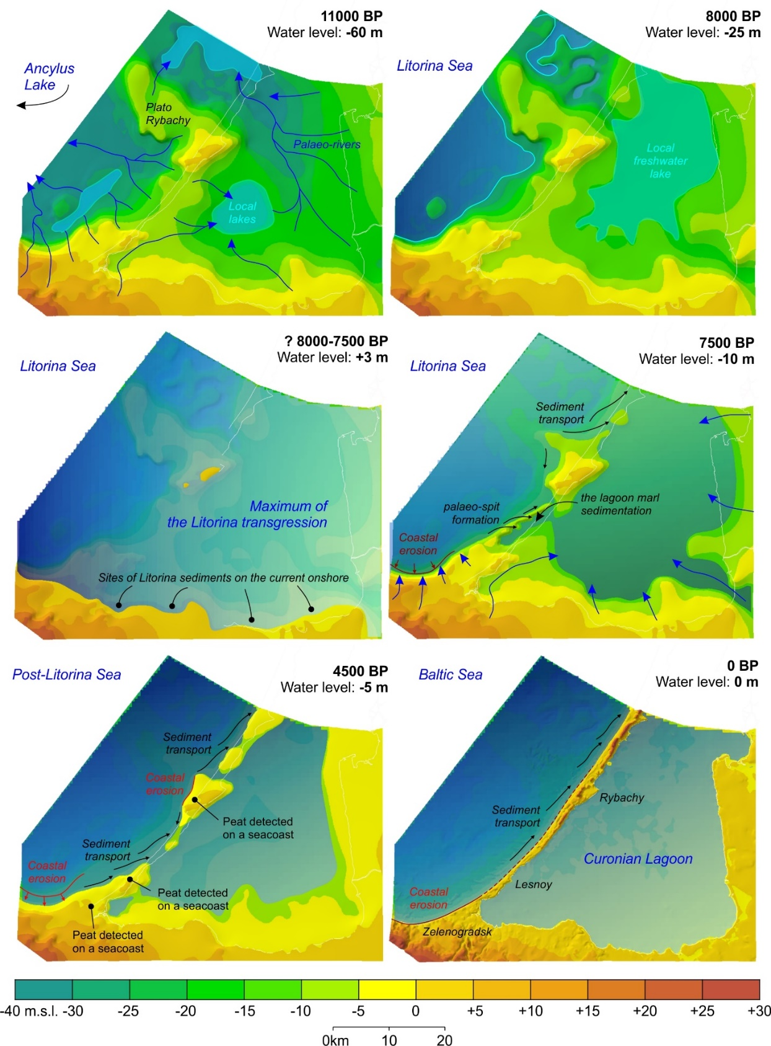
Fig. 3. Palaeogeographical reconstruction of Holocene development of the Curonian Spit area [25].

Geological settings and postglacial history of the Vistula Spit area, according to [12], [13], [14], are completely different, as it was earlier mentioned by [28]. There are only subaerial lacustrine–swampy or alluvial–deltaic complexes beneath the modern silty sediments of the gulf, whereas marine complexes are completely absent. Therefore, the Vistula lagoon has never been an open Litorina sea. An important feature of the Vistula Delta Plain and area under the Vistula Spit is consistent biogenic layer, deposited between 9120 and 7330 kal years B.P. Palaeoenvironment of long-term biogenic accumulation is interpreted as huge plain with channels and shallow swamps and peat logs in depressions. Within Vistula Spit this layer is covered by marine Litorina sands and dunes [13].
According to detailed palaeoreconstructions [14], during the Ancylus Lake, the coastal line was situated below recent sea level, within the Gdansk Basin, forming vast open bay with advanced palaeo-Vistula deltas. As a result of deltaic deposits erosion, extensive barrier beaches formed in the coastal zone and Aeolian processes started. During Early Litorina time shoreline shifted landward, within the central part of recent Vistula Lagoon the small, partly isolated lake occurred. During the Litorina transgression (by 8000 kal years BP), coastal line shape became for the first time similar with the modern one. Hel Spit developed; the Vistula Lagoon became separated from the sea by the Vistula Spit, most probably with several palaeostraits. The area of lagoon were larger than today by time of about 2500 kal years BP [14].
It is noteworthy, that numerous dating and other geological evidences prove very well this conception. However, some results of geological survey of the Russian part of the Vistula Lagoon coasts, according to which marine Litorina sands are mapped by the altitude of 2-5 m, as well as to hypotheses of palaeo-lagoon marl of the Vistula Spit formation. It should be mention, that Russian part of the Vistula Lagoon is much less studied in comparison with the Polish part. To complete the gaps in knowledge, new investigations are needed.
Modern lithodynamic processes
Analysis of materials and data figured out that most part of transported sediment forming total sediment flux migrated within the coastal zone of the Sambian Peninsula and the Curonian Spit consists of products of coastal and bottom erosion although one of the particularities of the Gdansk basin is predominance of river load in sediment balance. It can be explained in that, firstly the equilibrium profile is still under formation and erosion processes are taking place there and, secondly, the Vistula and Curonian lagoons act as traps for fluvial sediments. As it was noticed before for the Vistula Spit such fluvial sediment flux plays an important role in sediment balance.
Complex of erosion and accumulation processes leading to smoothing of irregularities of coastal line (bays, capes) is the tendency of modern development of Kaliningrad region coasts. Common pattern of long-shore sediment transport described in literature depicts two sediment fluxes directed to the north-west and southeast from the Sambian Peninsula (Cape Taran). On an underwater slope of the northern part of the Sambian Peninsula and the Curonian Spit sandy material migrates within so-called morpho-lithodynamics cells [29]. McLaren method [30] was applied to determine sediment transport direction of the underwater slope restricted by isobaths -30 m (zone of active wave influence) [31]. Results show dependence of sediment movement on morphological properties of the coastal zone – points of fluxes divergence are associated with capes; outcrops of moraine and pre-quaternary deposits are a source of material to be transported.
- CONCLUSION
Synthesis of long-term geological research of the Russian part of the southeastern Baltic and its coastal zone allowed to establish boundaries, time of forming and structure of the Sambian morpho-lythodynamic marine and coastal system. New geological and geophysical data allowed to produce palaeogeographical schemes of Holocene development of the Curonian Spit area. Comparative analyses of the Curonian and Vistula Spits areas revealed significant differences of their development in Late Pleistocene and Early Holocene, when the coastal zone of study area consisted on several morpho- lithodymanic systems.
The Curonian Spit was developed during Holocene on postglacial surface (e.g. glacial moraine ridges remains) as polygenic accretion form. During the first stages of the Curonian Spit development (regressive phase after Litorina transgression maximum) both cross-shore and longshore sediment transport were sources of sediment material, as a result of erosion of the Sambian Peninsula, Rybachy Plateau and deltaic sediments. Smoothed contour of the spit shoreline was formed during last 5000 years mainly as a result of longshore sediment drift.
The Vistula Spit area, according to [14], were located onshore by the time of the Litorina transgression, when the coastal line shape became for the first time similar with the modern one. Hel Spit developed; the Vistula Lagoon became separated from the sea by the Vistula Spit, most probably with several palaeostraits [14].
Consequently, lagoon systems of the South-Eastern Baltic became morphologically likeness during last 5000 years, when the Curonian and Vistula Spits and Lagoons had similar configurations, the lagoons became sediment traps for alluvial material of Neman and Vistula and Pregola rivers, and longshore and sediment transport became one of the most important coastal processes of marine shores.
The work was supported by the Russian Scientific Fund (grant 14-37-00047).
V. References
- A.I. Blazhchishin, “Flooded Dunes and Deposits of Construction Materials on the Sea Underwater Slope of the Curonian Spit,” Problems of Investigation and Protection of Nature at the Curonian Spit, pp. 59-67, 1998, in Russian.
- V.L. Boldyrev and O.I. Ryabkova, “Coastal Zone Processes Dynamics of the Baltic Sea (Kaliningrad Region),” Proc. Rus. Geographical Soc., vol.133. no.5, pp. 41-48, 2001, in Russian.
- G.S. Kharin and S.G. Kharin, “Geological Structure and Composition of the Curonian Spit (Baltic Sea),” Lithology and Miner. Resources, vol. 41, issue 4, pp.3 17-323, 2006.
- E.N. Badyukova, L.A. Zhindarev, S.A. Lukyanova and G.D. Solovyeva, “Curonian Spit: Genesis and Development,” Quaternary International, vol. 167, pp. 21-27, 2007.
- L.A. Zhindarev, O.I. Ryabkova and V.V. Sivkov, “Geology and Geomorphology of Marine Coasts,” Oil and Environment of Kaliningrad Region, vol. II: Sea, pp. 19-37, 2012, in Russian.
- A. Bitinas, R. Zaromskis, S. Gulbinskas, A. Damusyte, G. Zilinskas and D. Jarmalavicius, “The Results of Integrated Investigations of the Lithuanian Coast of the Baltic Sea,” Geology, Geomorphology, Dynamics and Human Impact. Geological Q., vol. 49 (4), pp. 355-362, 2005.
- A. Damušytė, “Post-glacial Geological History of the Lithuanian Coastal Area,” Summary of doctoral dissertation, Vilnius, 84 p., 2011.
- Zh. Gelumbauskaite, “Methods and Results Study of Ancient Coastal Levels Deformations of the SE Baltic Sea,” Baltica, vol.7, pp. 95–104, 1982.
- V.K. Gudelis, L.S. Lukoshevichus, G.I. Klejmenova and E.M. Vishnevskaya, “Geomorphology and Late-after-glacial Bottom Sediments of the South-eastern Baltic,” Baltica, vol.6, pp. 245–256, 1977, in Russian.
- M. Kabailienė, “Kursiu Nerija Spit and the Kursiu Marios Lagoon: Geological Structure, Origin and Development During Late Glacial and Holocene,” Abstr. Excursion Guide, The fifth marine geological conference «The Baltic», pp. 134-142, 1997.
- O. Pustelnilovas, “The Development of Kursiu Marios Lagoon on the Sedimentological Data,” Abstr. Excursion Guide, The fifth marine geological conference «The Baltic», pp. 149-155, 1997.
- J. E. Mojski, “The Evolution of the Southern Baltic Coastal Zone,” Oceanologia, vol.42, no.3, pp. 285–303, 2000.
- A. Tomczak, “Geological Structure and Holocene Evolution of the Polish coastal zone,” J. Coast. Res., no. 22, pp. 15-32, 1995.
- S. Uscinowicz, “Relative Sea Level Changes, Glacio-isostatic Rebound and Shoreline Displacement in the Southern Baltic,” Pol. Geological Inst. Special Papers, vol.10, 79 p., 2003.
- V.A. Zagorodnyh, T.A. Kunaeva, “Geology and Economic Deposits of Kaliningrad region,” 171 p., 2005, in Russian.
- Atlas of Geological and Environmental Geological Maps of the Russian Area of the Baltic Sea, Editor O.V. Petrov, St. Petersburg, VSEGEI, 78 p., 2010, in Russian.
- N.V. Lukyanova, Y.B. Bogdanov, O.V. Vasiliev, G.P. Vargin, V.R. Verbitsky, N.R. Gorbatsevich, et al., “State Geological map of the Russian Federation,” 1:1 000 000 scale (third generation). Central European Series. Sheet-N-(34) - Kaliningrad. Explanatory note, St. Petersburg, VSEGEI, 226 p., 2011, in Russian.
- A.I. Blazhchishin, V.L. Boldyrev, A.N. Efimov and I.A. Timofeev, “Ancient Coastal Levels and Formations in the South-eastern Baltic Sea,” Baltica, vol. 7, pp. 57–64, 1982, in Russian.
- V. Sivkov, D. Dorokhov and M. Ulyanova, “Submerged Holocene Wave-Cut Cliffs in the South-eastern Part of the Baltic Sea: Reinterpretation Based on Recent Bathymetrical Data,” The Baltic Sea Basin, Cent. East. Eur., pp. 203-217, 2011.
- B.G. Anderson and H.W. Borns, The Ice Age World, Scandinavian University Press, Oslo, 208 p., 1994.
- I.I. Krasnov, K. Duphorn and A.Vogese, “International Quaternary Map of Europe,” scale 1:2500000, 1971.
- L. Ž. Gelumbauskaitė, J. Šečkus, “Late–Glacial–Holocene History in Curonian Lagoon (Lithuanian sector),” Baltica, vol. 18, no.2, pp. 77-82, 2005.
- J. Harff and M. Meyer, “Coastlines of the Baltic Sea – Zones of Competition Between Geological Processes and a Changing Climate: Examples from the Southern Baltic,” The Baltic Sea Basin, Cent. East. Eur., pp. 149-164, 2011.
- O. Vestøl, “Determination of Postglacial Land Uplift in Fennoscandia from Levelling, Tide-gauges and Continuous GPS Stations Using Least Squares Collocation,” J. Geodesy, no.80, pp. 248-258, 2006.
- A.Yu. Sergeev, “The Palaeogeographical Reconstruction of the Curonian Spit Area in the Late Pleistocene – Holocene,” Reg. Geology Metallogeny, no. 62, pp. 34-44, 2015, in Russian.
- A. Y. Sergeev, V. A. Zhamoida, D. V. Ryabchuk, I. V. Buynevich, V. V. Sivkov, D. V. Dorokhov et al., “Genesis, Distribution and Dynamics of Lagoon Marl Extrusions along the Curonian Spit, Southeast Baltic Coast,” Boreas, 10.1111/bor.12177. ISSN 0300-9483.
- A. Sergeev, V. Sivkov, V. Zhamoida, D. Ryabchuk, A. Bitinas and J. Mažeika, “Holocene organic-rich Sediments within the Curonian Spit Coast, the South-eastern Baltic Sea,” Baltica, , vol.28, no.1, pp. 41-50, 2015.
- E.N. Badyukova, L.A. Zhindarev, S.A. Lukyanova and G.D. Solovyeva, “The Geological-geomorphological Structure of the Baltic (Vistula) Spit,” Oceanology, vol. 51, no. 4, pp. 632–639, 2011.
- A.N. Babakov, “Evolution of Ideas about Structure of Long-shore Sediment Transport in the South-eastern Baltic,” Lithodynamics of Ocean Bottom Contact Zone, pp. 56-58, 2009, in Russian.
- P. McLaren and D. Bowles, “The Effects of sediment transport on grain-size distributions,” J. of Sediment. Petrology, vol.55, no.4, pp. 0457-0470, 1985.
- E.V. Dorokhova and D.V. Dorokhov, “Sediment Mapping and Transport Pathways in the Nearshore Zone of the Russian part of South-Eastern Baltic Sea,” EMECS’11 – SeaCoasts’26 Conference Proc., 2016, in press.

